Splunk Home Lab Final Report
Mini SOC Simulation (Splunk Enterprise + BOTS v2)
Author: Tam Tran
Date: December 29, 2025

Executive Summary
This project documents a hands-on Splunk lab designed to simulate core Security Operations Center (SOC) workflows: log ingestion, search-driven threat hunting, basic detection engineering, and communicating findings. The lab ingests multiple data sources (Windows, Linux, network/IDS) and uses the Splunk BOTS v2 dataset to identify suspicious activity and produce portfolio-ready artifacts (SPL searches, screenshots, and a short incident-style write-up).

Lab Environment
Key components used in this lab:
- Splunk Enterprise (web UI used for searching, reporting, and visualizations)
- BOTS v2 dataset indexed into Splunk (index=botsv2)
- Network / IDS telemetry (Suricata alerts)
- Windows Security logs (EventCode 4625 failed logons)
- Supplemental sources (e.g., syslog, perfmon, MySQL telemetry present in BOTS v2)
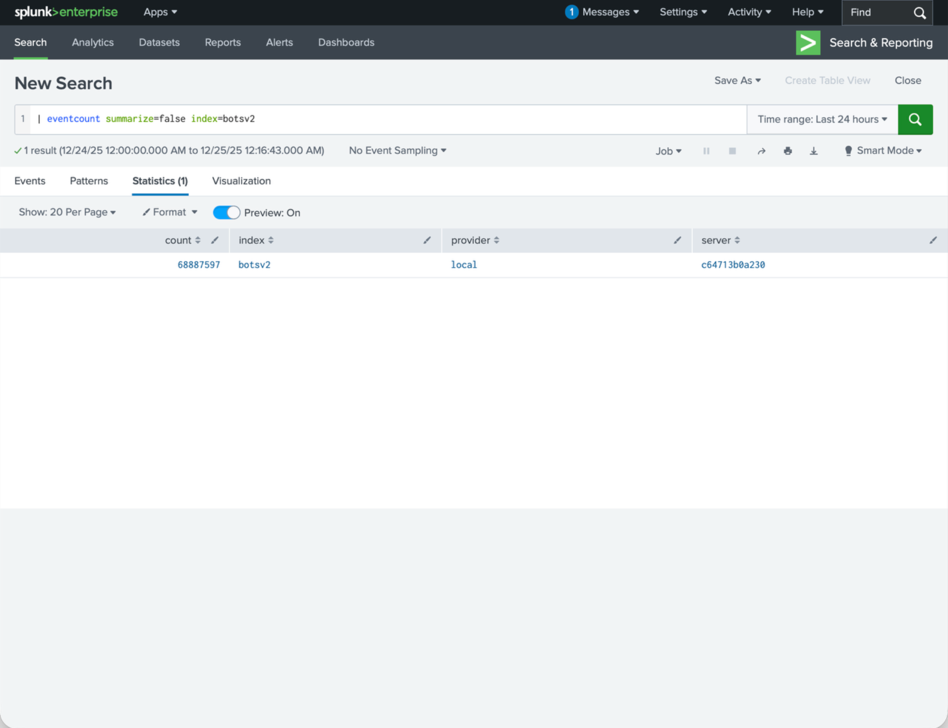
Figure 1. Validation that the BOTS v2 dataset is present in Splunk (eventcount over index=botsv2).
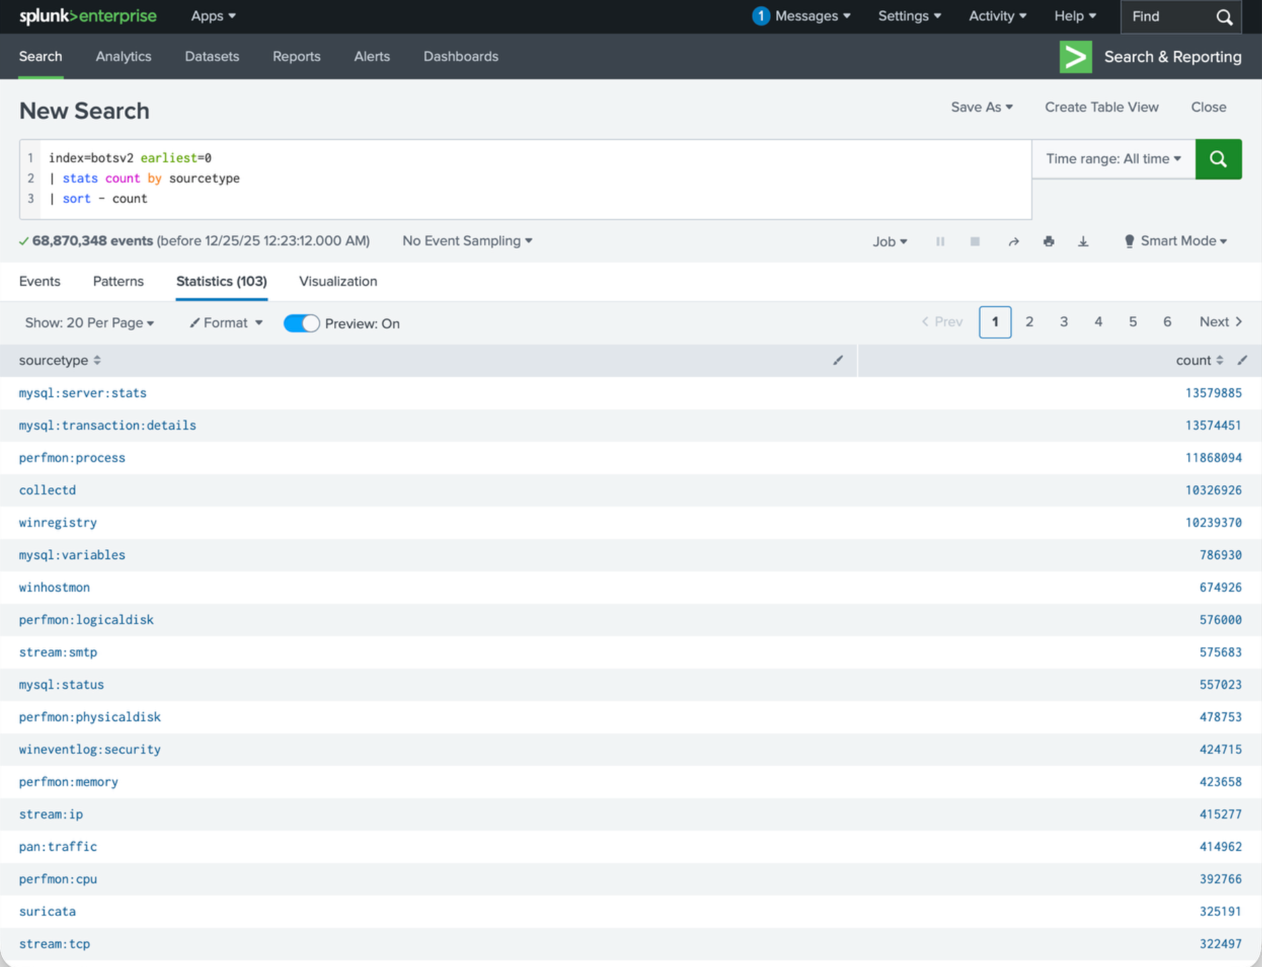
Figure 2. Top sourcetypes in index=botsv2 (example view showing breadth of ingested data sources).

Work Completed

Week 1 – Foundations
- Deployed Splunk and confirmed access to Search & Reporting.
- Rebuilt SPL fundamentals (filters, stats, timechart, sorting, and limiting).
- Validated baseline ingestion and explored the event model (index, sourcetype, host).

Week 2 – Security Data & Use Cases
- Expanded the dataset coverage by exploring key security-relevant sourcetypes (Windows Security, Suricata IDS).
- Built or iterated on a Security Operations overview dashboard to summarize security telemetry at a glance.
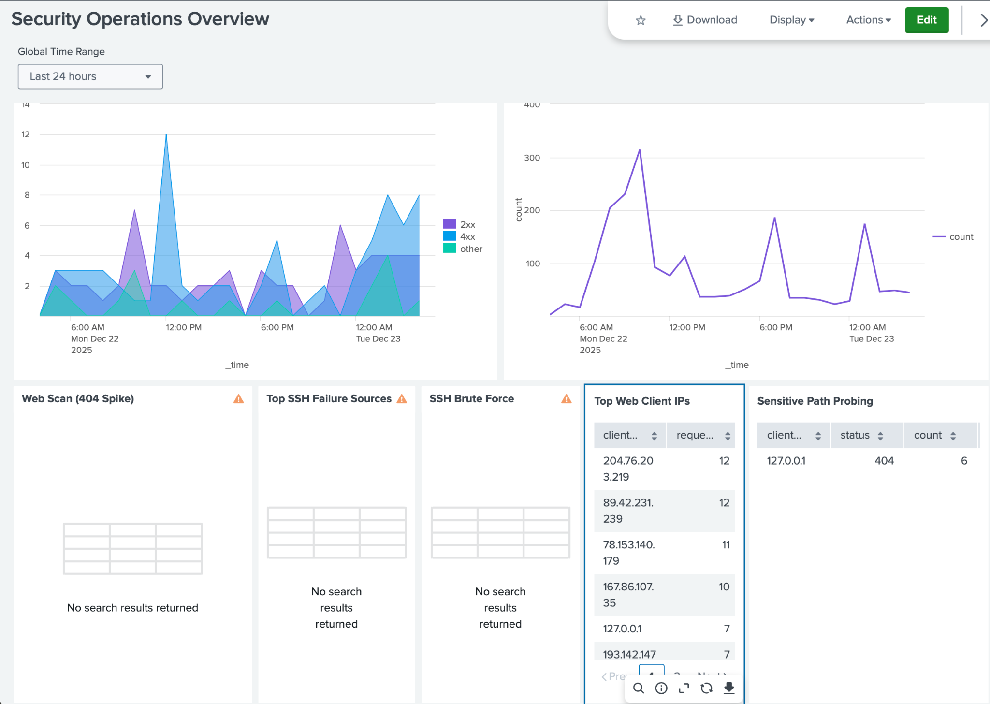
Figure 3. Example Security Operations overview dashboard (Week 2 deliverable).

Week 3 – SOC Analyst Practice
The Week 3 focus was threat hunting and surfacing suspicious patterns using a repeatable process:
1) start broad (high-signal sources like IDS + Windows Security logs),
2) aggregate and rank (stats/sort/head),
3) pivot to time trends (timechart) and scoping queries to support an incident-style narrative.

Week 3 Findings (Threat Hunting)
Below are three high-signal patterns identified from the ingested data. Each includes the SPL used, what was observed, and a short triage interpretation. Because BOTS v2 is a simulated dataset, these findings are treated as practice detections rather than confirmed production incidents.

Finding 1: Repeated Failed Logons (Windows EventCode 4625)
Repeated Windows failed logons can indicate password spraying, brute-force attempts, or misconfigured services. In the dataset, EventCode=4625 is used to scope failed authentication attempts.
SPL used (top users and source IPs generating failed logons):
index=botsv2 sourcetype=wineventlog:security EventCode=4625 earliest=0
| eval user=coalesce(TargetUserName, Account_Name, AccountName, SubjectUserName, user, User)
| eval src_ip=coalesce(IpAddress, SourceNetworkAddress, Source_Network_Address, src_ip, src, clientip)
| eval user=if(isnull(user) OR user="" OR user="-" , "unknown_user", user)
| eval src_ip=if(isnull(src_ip) OR src_ip="" OR src_ip="-", "unknown_ip", src_ip)
| stats count as fails by user, src_ip
| sort - fails
| head 20
SPL used (time trend to visualize spikes):
index=botsv2 sourcetype=wineventlog:security EventCode=4625 earliest=0
| eval src_ip=coalesce(IpAddress, SourceNetworkAddress, Source_Network_Address, src_ip, src, clientip)
| eval src_ip=if(isnull(src_ip) OR src_ip="" OR src_ip="-", "unknown_ip", src_ip)
| timechart span=1h count by src_ip limit=10
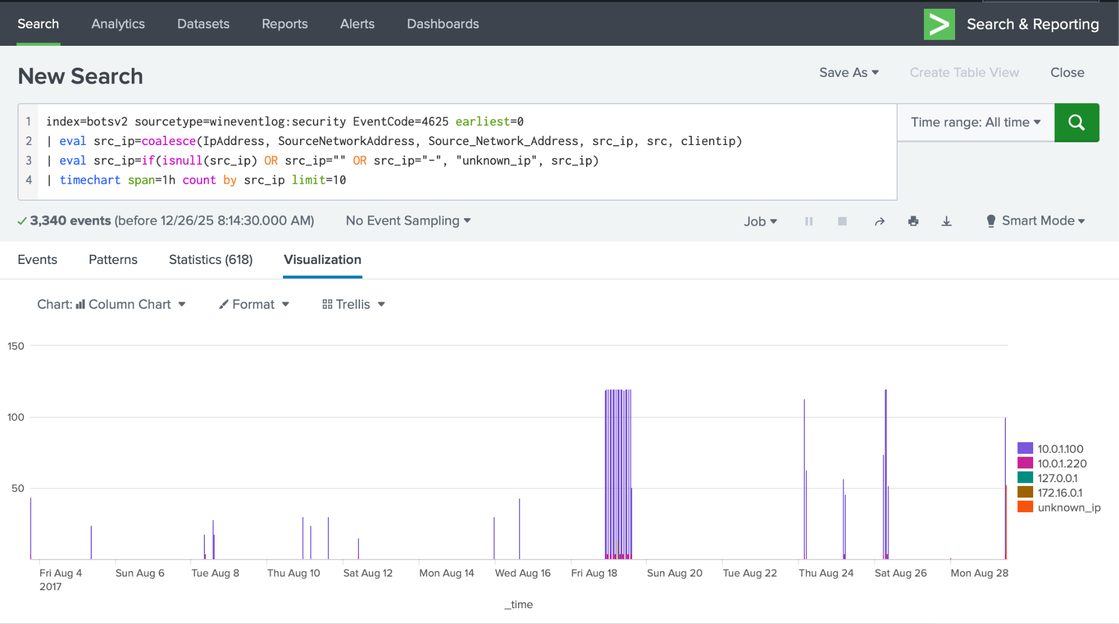
Figure 4. Time trend of Windows failed logons (EventCode 4625) by source IP.
Observed pattern (from screenshots): a small number of source IPs dominate the failed logon volume. This is consistent with automated guessing or repeated authentication failures from a single host/service.
MITRE ATT&CK mapping (high-level):
- Credential Access → Brute Force (T1110)
- Credential Access → Password Spraying (T1110.003) (if many accounts targeted with few attempts each)
Recommended triage pivots (optional, if extending the project):
- Pivot from top src_ip into raw events to identify target accounts, logon types, and failure reasons.
- Check for successful logons (EventCode 4624) around the same timeframe to see if brute-force succeeded.

Finding 2: IDS Alerts Indicating Port 135 / RPC Scanning
Suricata alerts provide high-signal indicators for network-based reconnaissance. In the dataset, a large volume of alerts reference unusual Port 135 traffic, which is commonly associated with RPC activity and can show up during network discovery or exploitation attempts (especially when combined with SMB activity).
SPL used (identify Port 135/scan-related Suricata signatures):
index=botsv2 sourcetype=suricata earliest=0
| search alert.signature="*Port 135*" OR alert.signature="*135*" OR alert.signature="*SCAN*"
| stats count by src_ip, dest_ip, alert.signature
| sort - count
| head 20
SPL used (which destinations were most targeted for Port 135):
index=botsv2 sourcetype=suricata earliest=0
| search alert.signature="*Port 135*"
| stats count by dest_ip
| sort - count
| head 20
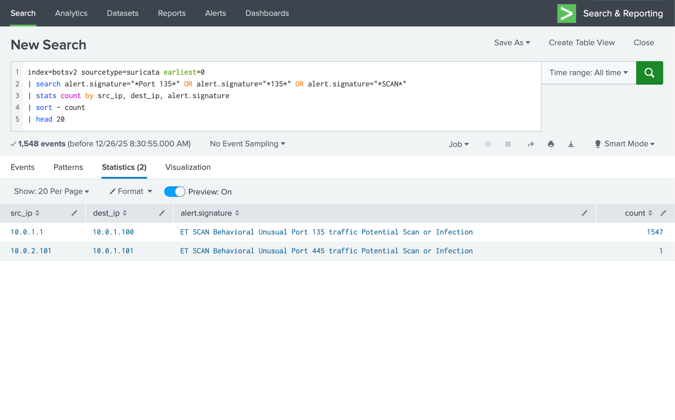
Figure 5. Suricata scan-related alerts ranked by count (Port 135 scan dominates the results).
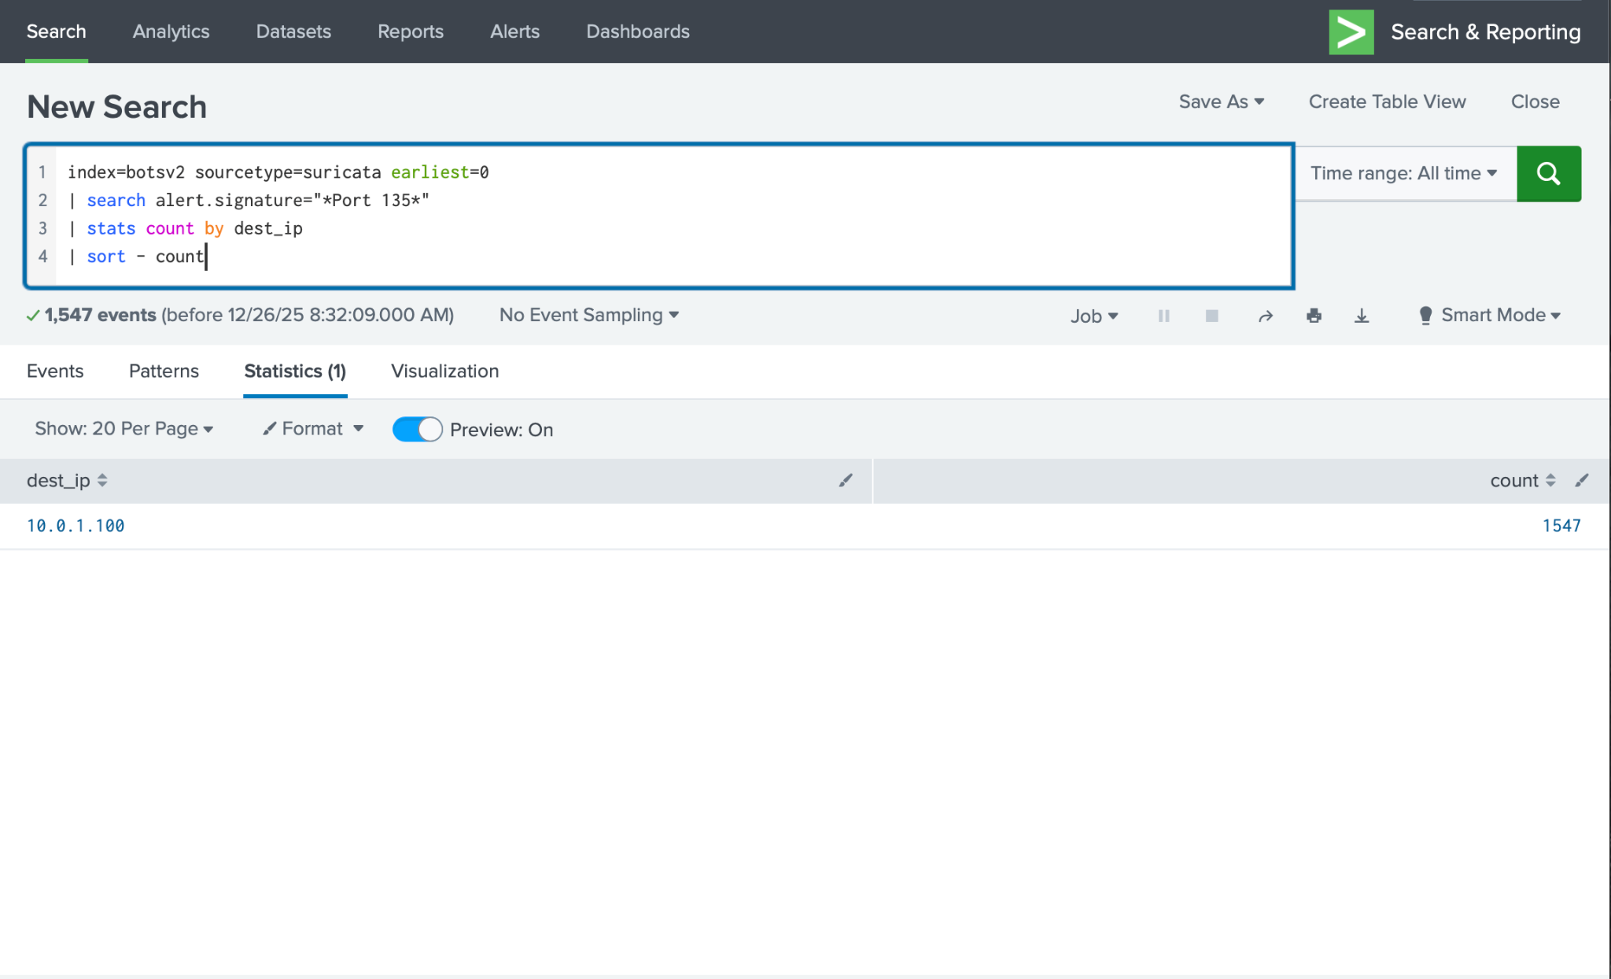
Figure 6. Port 135 scan destinations (dest_ip with highest alert count).
Observed pattern (from screenshots): a single source/destination pair accounts for nearly all Port 135 scan alerts, and a single destination IP is heavily targeted. That concentration is consistent with a host being scanned/reconnoitered or an intentionally simulated scan within BOTS v2.
MITRE ATT&CK mapping (high-level):
- Discovery → Network Service Discovery (T1046)
- Discovery → Remote System Discovery (T1018) (depending on context)
Recommended triage pivots:
- Pivot to related ports (e.g., 445/SMB) and correlate by src_ip/dest_ip and time.
- Check endpoint telemetry (Windows logs) on the targeted host around the scan timeframe.

Finding 3: Potential TOR-Related TLS Traffic (Suricata)
TOR usage can be benign (privacy) or suspicious (evasion / C2), depending on the environment. Suricata signatures referencing TOR or 'TLS possible TOR SSL traffic' were queried and summarized.
SPL used (find TOR/TLS signatures and top conversations):
index=botsv2 sourcetype=suricata earliest=0
| search alert.signature="*TOR*" OR alert.signature="*Tor*" OR alert.signature="*tor*" OR alert.signature="*TLS possible TOR*"
| stats count by src_ip, dest_ip, alert.signature
| sort - count
| head 50
SPL used (time trend of TOR/TLS alerts):
index=botsv2 sourcetype=suricata earliest=0
| search alert.signature="*TOR*" OR alert.signature="*TLS possible TOR*"
| timechart span=1h count by alert.signature limit=10
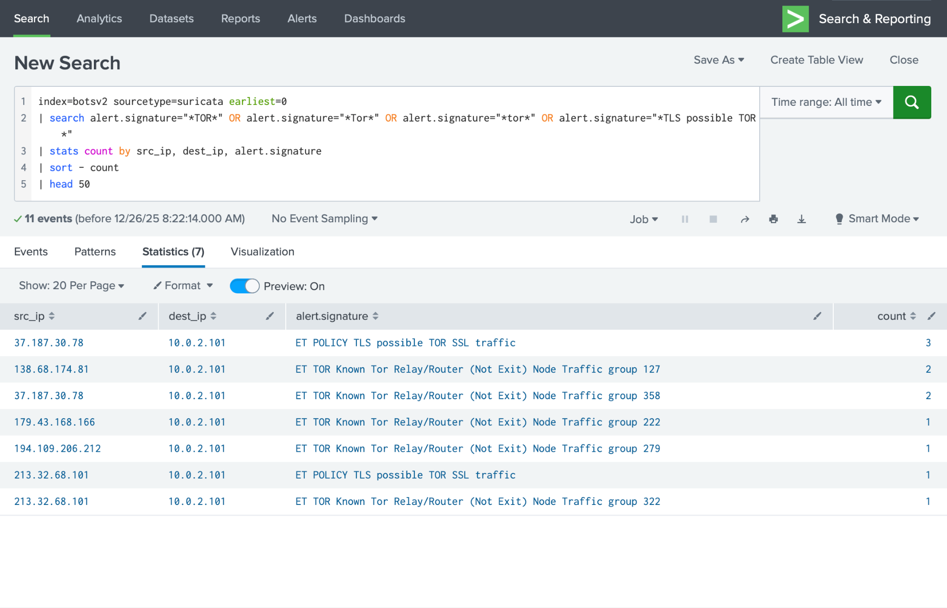
Figure 7. TOR/TLS-related Suricata alerts (src_ip, dest_ip, signature) ranked by count.
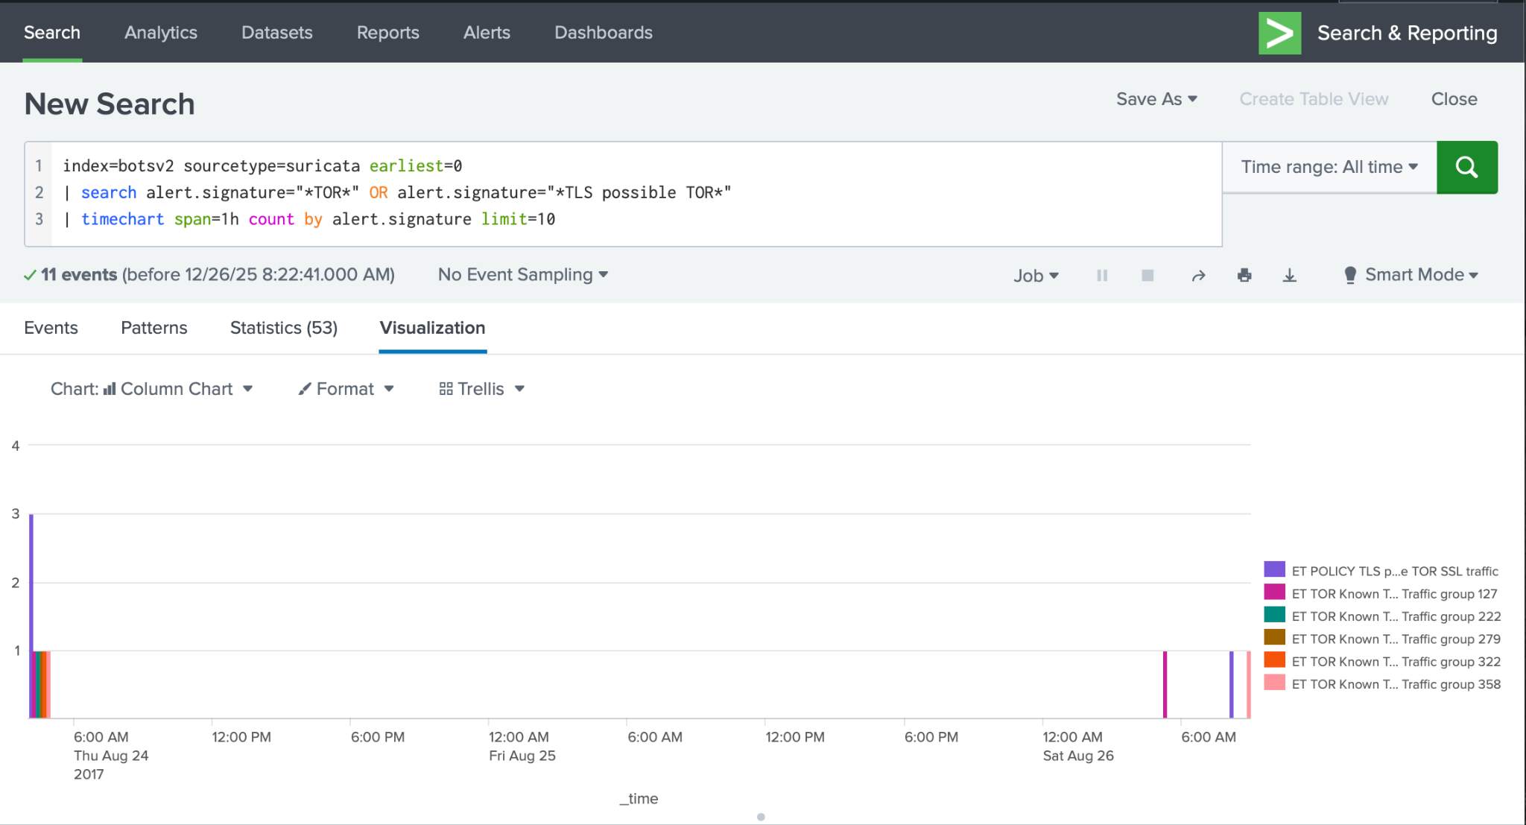
Figure 8. Time trend of TOR/TLS-related Suricata alerts (hourly).
Observed pattern (from screenshots): a small number of TOR-related signatures appear and are tied to a single internal destination IP. The volume is low compared to the Port 135 scan, but it is a clear example of a hunt-able pattern and a good portfolio artifact.
MITRE ATT&CK mapping (high-level):
- Command and Control → Proxy (T1090)
- Defense Evasion → Proxy (T1090) (when used to hide origin)
Recommended triage pivots:
- Pivot from dest_ip into proxy/DNS/web logs (if available) to identify domains and user agents.
- Check if the destination host also shows authentication anomalies or scan activity nearby in time.

Conclusion
This lab achieved its primary goal: demonstrate repeatable SOC-style workflows using Splunk. The project produced portfolio-ready evidence of (1) successful dataset ingestion, (2) a security overview dashboard, and (3) three threat-hunting findings supported by SPL + screenshots. If extending later, the next highest-impact upgrade would be turning one or two of these hunts into scheduled alerts with documented triage steps and an incident note template.

Appendix A: SPL Library (Copy/Paste)
- Validate BOTS v2 ingestion (eventcount):
index=botsv2 | eventcount summarize=false
- List top sourcetypes:
index=botsv2 earliest=0 | stats count by sourcetype | sort - count
- Failed logons – top users + src IPs:
index=botsv2 sourcetype=wineventlog:security EventCode=4625 earliest=0
| eval user=coalesce(TargetUserName, Account_Name, AccountName, SubjectUserName, user, User)
| eval src_ip=coalesce(IpAddress, SourceNetworkAddress, Source_Network_Address, src_ip, src, clientip)
| eval user=if(isnull(user) OR user="" OR user="-" , "unknown_user", user)
| eval src_ip=if(isnull(src_ip) OR src_ip="" OR src_ip="-", "unknown_ip", src_ip)
| stats count as fails by user, src_ip
| sort - fails
| head 20
- Failed logons – time trend:
index=botsv2 sourcetype=wineventlog:security EventCode=4625 earliest=0
| eval src_ip=coalesce(IpAddress, SourceNetworkAddress, Source_Network_Address, src_ip, src, clientip)
| eval src_ip=if(isnull(src_ip) OR src_ip="" OR src_ip="-", "unknown_ip", src_ip)
| timechart span=1h count by src_ip limit=10
- Port 135 scan – top conversations:
index=botsv2 sourcetype=suricata earliest=0
| search alert.signature="*Port 135*" OR alert.signature="*135*" OR alert.signature="*SCAN*"
| stats count by src_ip, dest_ip, alert.signature
| sort - count
| head 20
- Port 135 scan – top destinations:
index=botsv2 sourcetype=suricata earliest=0
| search alert.signature="*Port 135*"
| stats count by dest_ip
| sort - count
| head 20
- TOR/TLS possible TOR – top conversations:
index=botsv2 sourcetype=suricata earliest=0
| search alert.signature="*TOR*" OR alert.signature="*Tor*" OR alert.signature="*tor*" OR alert.signature="*TLS possible TOR*"
| stats count by src_ip, dest_ip, alert.signature
| sort - count
| head 50
- TOR/TLS possible TOR – time trend:
index=botsv2 sourcetype=suricata earliest=0
| search alert.signature="*TOR*" OR alert.signature="*TLS possible TOR*"
| timechart span=1h count by alert.signature limit=10

